Choose the number of clusters in K-Mean

Elbow Method:
Y-axis = Cost function J
X-axis = K (no. of clusters)
Not always clear Elbow

Number of K in KNN
- Generally, choose an odd number if the number of classes is even.
- Check model performance on different number of K
- Elbow Method

Bias
The inability of a machine learning method (like linear regression) to capture the true relationship is called Bias.

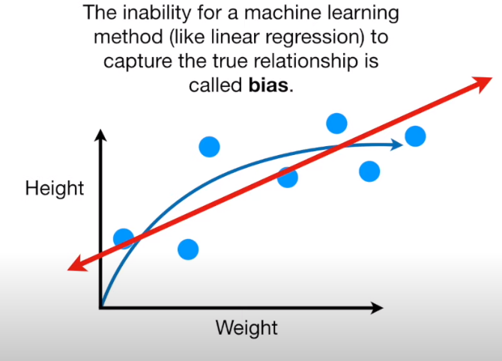
What is bias in ML
- Bias is like intercept added in a Linear equation
- A bias value allows you to shift the activation function to the left or right
- It is that output of the neural net when it has absolutely zero input

Different distance measures

Hamming Distance
It calculates the distance between two binary vectors, also referred to as binary strings or bitstrings for short. Hamming distance is the number of bit positions in which the two bits are different.
Perform XOR operation on two string of equal length and find total numbers of ones.
"karolin" and "kathrin" is 3.

Euclidean Distance
Euclidean distance calculate the distance between two real-valued vectors.
Most likely to use Euclidean when calculating the distance between two numerical values.
Euclidean distance is calculated as the square root of sum of squared distance between the two vectors.

Manhattan Distance (City Block Distance)

When to use
Useful to vectors when that describe objects on a uniform grid, like a chessboard or city block.
Its the sum of absolute difference between the two vectors.

Minkowski Distance
It is a generalization of the Euclidean distance and the Manhattan distance.
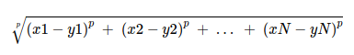
It is common to use Minkowski distance when implementing a machine learning algorithm that uses distance measures as it gives control over the type of distance measure used for real-valued vectors via a hyperparameter “p” that can be tuned.

Different types of Kernels
Kernels methods are a class of algorithms for pattern analysis. The function of kernel is to take data as input and transform it into the required form. Math Behind SVM .

Types
- Linear
  - If data is linearly separable
- Nonlinear- If data is non-linearly separable
  - Polynomial
    - It is popular in image processing.
  - Radial basis function (RBF)
    - For n dimensional dataset

Convex Hull OpenCV

